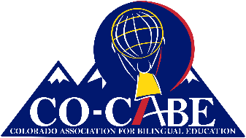
Colorado Association for Bilingual Education

CO-CABE Scholar Award 2021

DESCRIPTION
$10,000, four-year scholarship for a Colorado high school senior or undergraduate student planning to pursue a college degree to become a Bilingual Education teacher in Colorado.

ELIGIBILITY

High school seniors applying to higher education and not yet accepted are eligible to apply. (If selected, applicant must provide proof of acceptance to a Colorado institution of higher education before the scholarship money will be awarded.)

Applicants may apply for CO-CABE Scholars and CO-CABE Undergraduate Scholarship. Separate applications must be submitted.

Applicants receiving full scholarships or grants from other sources are not eligible for this scholarship.

Applicants must submit all the required application materials prior to the application deadline in order to be considered.

Applicants must be Bilingual. Applicants who receive the Seal of Biliteracy from their district will be given competitive priority. Finalists will be required to provide proof of bilingualism.

APPLICATION DEADLINE

The deadline for scholarship applications is 4 pm, May 1st, 2021. Scholarship recipients will be notified by May 30, 2021.

Please submit completed scholarship applications electronically to:
peter.vigil@cocabe.org

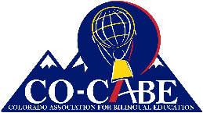
2021 CO-CABE Scholar Application Instructions

The scholarship application consists of four parts. You must submit all of them for your application to be complete.
- Part I: Information Sheet consisting of 7 questions.
- Part II: List of community service, awards, and recognitions that you have received.
  - The committee is especially interested in your involvement with culturally and linguistically diverse communities.
- Part III: Personal essay.
  - This essay should be typed, double spaced, 12 pt. font, with one- inch margins on all four sides.
  - Read the essay instructions carefully and be sure to respond directly to the questions posed.
  - This essay is a critical piece of your application and is considered heavily by the Scholarship Committee.
- Part IV: Two signed letters of recommendation.
  - At least one letter of recommendation must be from an educator (teacher, professor, counselor, school administrator, etc., who knows you personally).
  - Letters must be signed, scanned, and sent electronically.

APPLICATION DEADLINE

The deadline for scholarship applications is 4 pm, May 1st, 2021. Scholarship recipients will be notified by May 30, 2021.

Please submit completed scholarship applications electronically to:
peter.vigil@cocabe.org

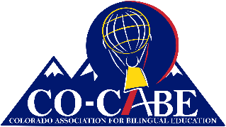
2021 CO-CABE Scholar Award Application
Part I
Applicant Information

Applicant Name: Click or tap here to enter text.

Mailing Address: Click or tap here to enter text.
Click or tap here to enter text.
Click or tap here to enter text.
Parent/Guardian: Click or tap here to enter text.
(if age 17 or younger)

Phone: Click or tap here to enter text.

E-Mail Address: Click or tap here to enter text.

Have you already been accepted to a university?  Yes ☐ No ☐ |  | If Yes, submit letter of acceptance
 |  | If No, submit letter of acceptance when you receive it.
Are you Bilingual/Multilingual?  Yes ☐ No ☐ | If Yes, in what languages? |  | Click or tap here to enter text.

APPLICATION DEADLINE

The deadline for scholarship applications is 4 pm, March 15, 2021. Scholarship recipients will be notified by May 30, 2021.

Please submit completed scholarship applications electronically to:
peter.vigil@cocabe.org

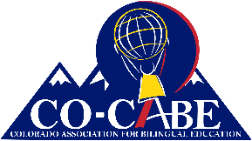
2021 CO-CABE Scholars Application
Part II
List of Community Service & Awards

For Part II submit a separate sheet that lists community service, work experience, awards, and recognitions that you have received. The committee is especially interested in your involvement with culturally and linguistically diverse communities. Please provide a list, not a narrative, and be sure to include your name.
Part III
Personal Essay
Part III consists of a five page (maximum) personal essay. This essay is a critical piece of your application and is considered heavily by the Scholarship Committee. Follow these instructions carefully and completely.
- This essay should be typed, double spaced, 12 pt. font, with one-inch margins on all four sides.
- Please include a cover sheet that includes your name and a title for your essay. The cover sheet is not counted toward the five page limit for your essay.
- There are four questions that you must respond to in your essay:
  - How did you become bilingual? For this question, provide a language autobiography describing how you acquired your languages.
  - Why do you believe Bilingual & Bicultural Education are important?
  - What influences–including people and/or events–have led you to seek this degree?
  - What do you plan to do with your degree?

Part IV
Letters of Recommendation
You must submit two signed letters of recommendation.
- At least one letter of recommendation must be from an educator (teacher, professor, counselor, school administrator, etc. who knows you personally).
- Letters must be signed, scanned, and sent electronically.

Finalist Interview
Applicants who are Finalists for the CO-CABE Scholar Award will be contacted for a personal interview with the members of the CO-CABE Scholars Committee. Finalists will be expected to demonstrate their bilingualism during the interview.

APPLICATION DEADLINE

The deadline for scholarship applications is 4 pm, May 1st, 2021. Scholarship finalists will be notified by May 30, 2021.

Please submit completed scholarship applications electronically* to:
peter.vigil@cocabe.org

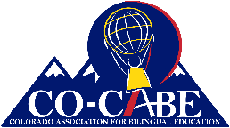
2021 CO-CABE Scholars Information
Please Read Carefully

CO-CABE Scholars Award is a 4 year, $10,000 scholarship intended to support a student who is pursuing a teaching degree to become a bilingual teacher in Colorado. The funds will be disbursed throughout the four years at a rate of $2,500 per year. In addition to the scholarship funds, the CO-CABE Scholar will receive a Lifetime Membership in CO-CABE.

The CO-CABE Scholar will be asked to complete certain requirements throughout their college years. Some of these requirements will be completed every year and others will only be required once during the four years of the scholarship. CO-CABE will provide advice and support to help the CO-CABE Scholar schedule and prepare to meet the expectations described below. A CO-CABE member will be appointed to serve as the CO-CABE Contact with the CO-CABE Scholar.

- The CO-CABE Scholar will be requested to keep the CO-CABE Contact informed of current contact information and any changes so that the CO-CABE Scholar and CO-CABE can remain in contact with each other.
- The CO-CABE Scholar will be asked to respond promptly to inquiries from the CO-CABE Contact.
- The CO-CABE Scholar will be asked to seek support from the CO-CABE Contact to allow CO-CABE to provide whatever support it can to help ensure the success of the CO-CABE Scholar.
- The CO-CABE Scholar will be asked to cooperate with CO-CABE and allow CO-CABE to use her/his name, photo, and general information to announce, advertise, promote, etc. the CO-CABE Scholar and the CO-CABE Scholars Program.
- The CO-CABE Scholar will be asked to make one presentation to CO-CABE members at a CO-CABE Conference.
- The CO-CABE Scholar will be asked to make one presentation to high school or college students about their experience as a CO-CABE Scholar.
- The CO-CABE Scholar will be asked to be a member of the CO-CABE Scholar Committee to assist in selecting the next CO-CABE Scholar.
- The CO-CABE Scholar will be asked to volunteer at a community event for culturally and linguistically diverse populations.
- The CO-CABE Scholar will be asked to provide documentation of adequate progress towards achieving their degree during each year of the scholarship.
- Prior to receiving the CO-CABE Scholar award, the CO-CABE Scholar will be asked to enter into a written agreement with CO-CABE agreeing to the requirements and expectations of the CO-CABE Scholar Program.

